1. Title of the Project

2. Introduction
Road accidents often occur due to poor visibility, damaged road surfaces, and delayed driver reaction. Detecting hazards such as potholes, cracks, and speed breakers in real time can significantly improve road safety. Most modern solutions depend on high-performance GPUs and deep learning models, which increase system cost and power consumption.
This project proposes a low-cost embedded vision system that performs real-time road hazard detection and night vision enhancement using classical computer vision techniques. The system operates efficiently on a compact processing platform without requiring specialized AI hardware.

3. Problem Statement
Existing road monitoring and ADAS solutions:
- Require high computational resources,
- Consume significant power,
- Are expensive for large-scale deployment,
- Perform poorly in low-light environments without additional sensors.
Therefore, there is a need for a computationally efficient and affordable system capable of detecting road hazards and improving visibility under varying lighting conditions.

4. Objectives
- To design a real-time road hazard detection system using an embedded platform.
- To detect potholes, cracks, and speed breakers using image processing techniques.
- To implement a night vision enhancement module for low-light conditions.
- To estimate motion and predict potential collision risks.
- To achieve real-time performance without GPU acceleration.

5. Methodology
The proposed system follows a structured processing pipeline:
- Image Acquisition
  - Capture video frames using a CSI-based camera connected to an embedded processor.
- Preprocessing
  - Select Region of Interest (road surface area).
  - Convert image into HSV color space for brightness control.
- Night Vision Enhancement
  - Apply brightness amplification.
  - Use adaptive histogram equalization (CLAHE) to improve contrast.
- Road Surface Analysis
  - Perform texture analysis using statistical variance.
  - Detect edges using Canny and Sobel operators.
- Feature Extraction and Classification
  - Extract contours and analyze geometric properties.
  - Classify hazards based on shape characteristics.
- Motion Analysis
  - Apply dense optical flow for motion tracking.
  - Estimate Time-To-Collision (TTC) for risk prediction.
Block Diagram of the System
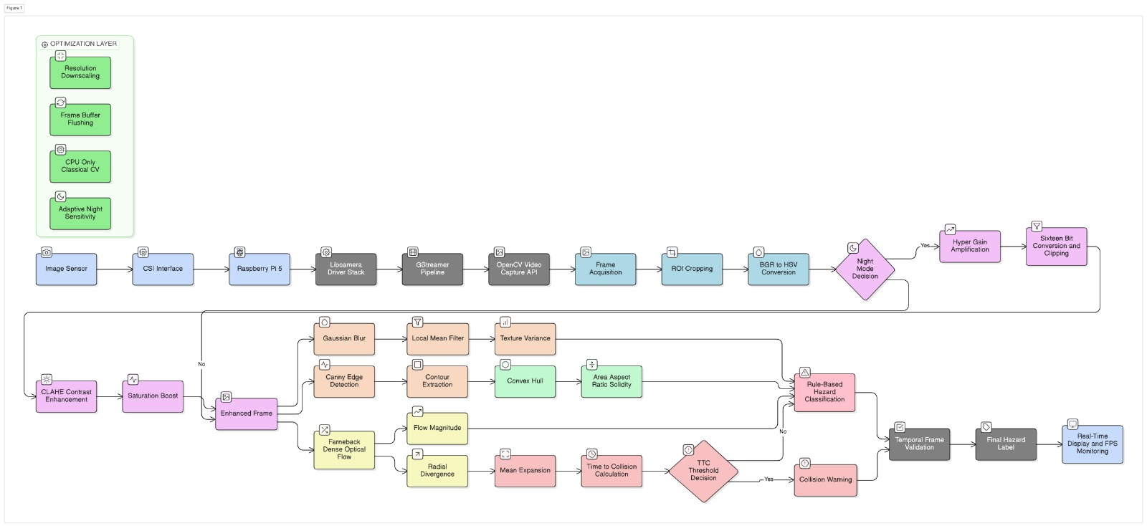

6. Hardware and Software Requirements

Hardware
- Raspberry Pi 5
- CSI Pi Camera (OV5647 Sensor)
- Power supply and storage module

Software
- Embedded Linux OS
- Python Programming
- OpenCV
- NumPy
- libcamera and GStreamer

7. Expected Outcomes
- Real-time detection of road hazards.
- Enhanced night-time visibility.
- Stable operation at approximately 20–30 FPS.
- Reduced computational and power requirements.
- A deployable low-cost ADAS prototype.

8. Applications
- Advanced Driver Assistance Systems (ADAS)
- Smart surveillance vehicles
- Autonomous navigation research
- Road condition monitoring systems
- Smart transportation and safety systems

9. Advantages of the Proposed System
- Low-cost implementation
- GPU-free processing
- Real-time performance
- Works in day and night conditions
- Lightweight and energy efficient

10. Future Scope
- Integration with vehicle braking or alert systems.
- Addition of GPS-based hazard mapping.
- Fusion with radar or ultrasonic sensors.
- Deployment using edge AI accelerators for hybrid systems.

11. Conclusion
The proposed system provides an efficient and practical solution for road safety by combining image enhancement, texture analysis, and motion estimation techniques. It demonstrates that reliable road hazard detection can be achieved using optimized classical vision algorithms on embedded hardware, making it suitable for scalable and cost-effective ADAS deployment.

